In Java, operators are special symbols or keywords that are used to perform operations on variables and values.

**Types of operators**

**1. Arithmetic Operators**

These operators are used to perform mathematical operations like addition, subtraction, multiplication, division, and modulus.

| **Operator** | **Description** | **Example** |
| --- | --- | --- |
| + | Addition | a + b |
| - | Subtraction | a – b |
| * | Multiplication | a * b |
| / | Division | a / b |
| % | Modulus (Remainder) | a % b |

**Example:**

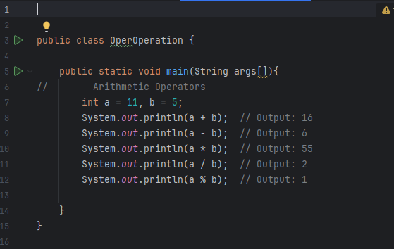**2. Relational (Comparison) Operators**

These operators are used to compare two values and return a boolean result (true or false).

| **Operator** | **Description** | **Example** |
| --- | --- | --- |
| == | Equal to | a == b |
| != | Not equal to | a != b |
| > | Greater than | a > b |
| < | Less than | a < b |
| >= | Greater than or equal to | a >= b |
| <= | Less than or equal to | a <= b |

**Example:**

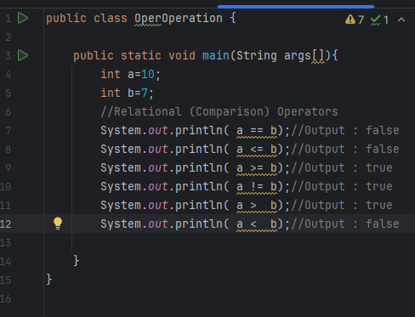

**3. Logical Operators**

Logical operators are used to combine multiple Boolean expressions or values and return a Boolean result.

| **Operator** | **Description** | **Example** |
| --- | --- | --- |
| && | Logical AND (true if both operands are true) | a && b |
| `|| | Logical OR | `a||b |
| ! | Logical NOT (inverts the boolean value) | !a |

**Example:**

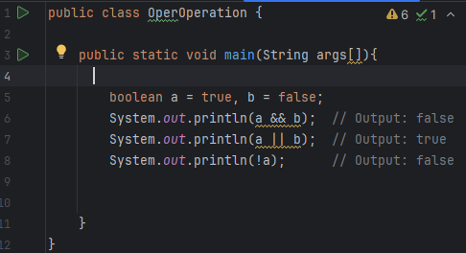

**4. Assignment Operators**

Assignment operators are used to assign values to variables.

| **Operator** | **Description** | **Example** |
| --- | --- | --- |
| = | Simple assignment | a = 5 |
| += | Addition assignment | a += 5 |
| -= | Subtraction assignment | a -= 5 |
| *= | Multiplication assignment | a *= 5 |
| /= | Division assignment | a /= 5 |
| %= | Modulus assignment | a %= 5 |

**Example:**

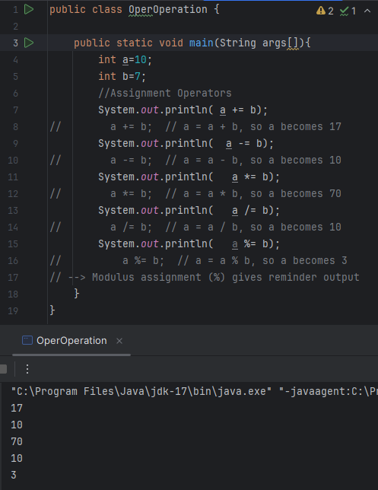

**5. Unary Operators**

Unary operators operate on a single operand. They are used to perform operations such as incrementing or decrementing the value of a variable.

| **Operator** | **Description** | **Example** |
| --- | --- | --- |
| + | Unary plus (indicates a positive value) | +a |
| - | Unary minus (negates the value) | -a |
| ++ | Increment (increase by 1) | a++ or ++a |
| -- | Decrement (decrease by 1) | a-- or --a |
| ! | Logical NOT (negates boolean value) | !a |

Example:

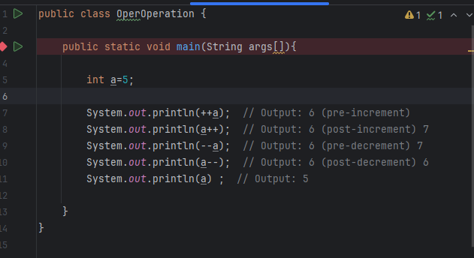

**6. Bitwise Operators**

Bitwise operators work on bits and perform bit-by-bit operations.

| **Operator** | **Description** | **Example** |
| --- | --- | --- |
| & | Bitwise AND | a & b |
| | | a|b | Bitwise OR |
| ^ | Bitwise XOR | a ^ b |
| ~ | Bitwise NOT | ~a |
| << | Left shift | a << b |
| >> | Right shift | a >> b |
| >>> | Unsigned right shift | a >>> b |

**Example:**

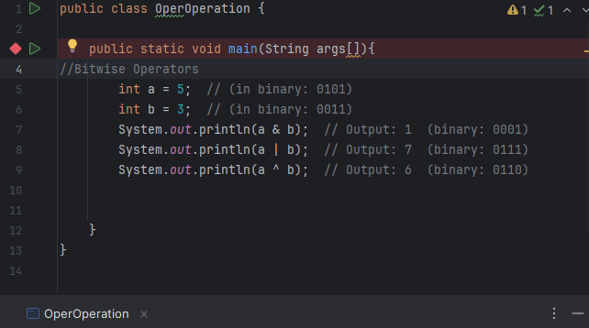

**7. Ternary Operator**

The ternary operator is a shorthand for the if-else statement. It takes three operands and returns one of two values based on a condition.

| **Operator** | **Description** | **Example** |
| --- | --- | --- |
| ?: | Ternary (conditional) operator | condition? expr1: expr2 |

Example:

